Figure 14 from CT course
Adam SZ, Rabinowich A, Kessner R, Blachar A. Spectral CT of the abdomen: Where are we now? Insights Imaging. 2021;12(1):138. doi:10.1186/s13244-021-01082-7
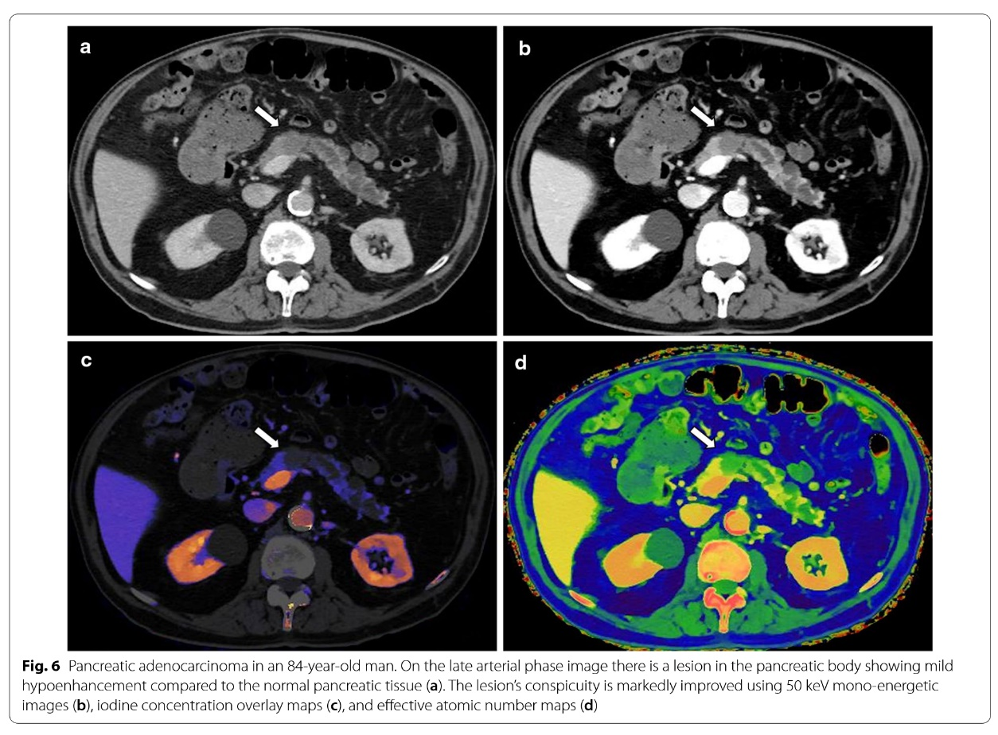
Figure 14: Pancreatic adenocarcinoma. A mildly hypo-enhancing lesion is seen in the pancreatic body (arrow) in the later arterial phase image (a). The lesion’s conspicuity is improved in a 50 keV monoenergetic image (b), iodine overlay image (c) and atomic number map (d).²

